Web Application Security Testing

I.Security Report

Vulnerability Assessment of DVWA(Damn Vulnerable Web Application)

1. Setting Up DVWA on Ubuntu.

Downloading Apache, PHP and mariadb-server(mySQL)(LAMP).

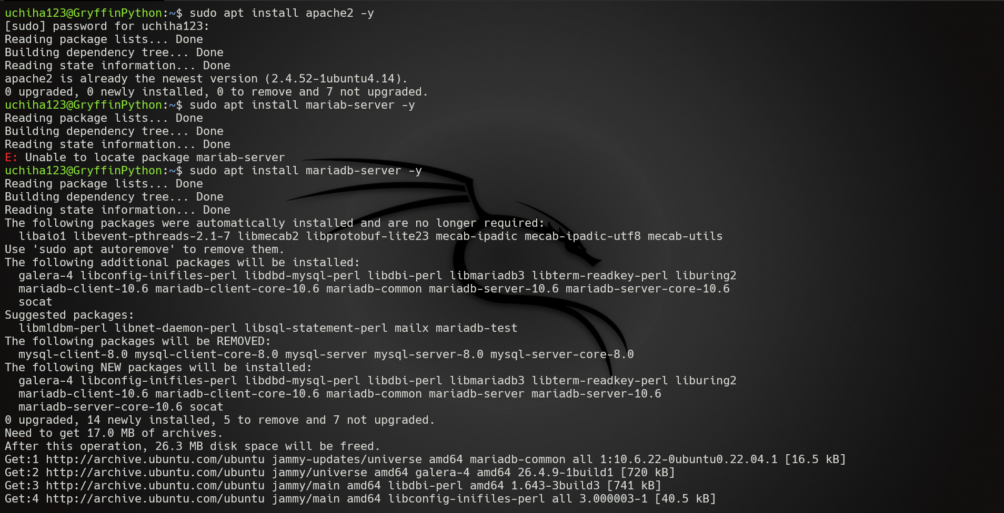

First, install the http server in our Ubuntu machine that allows us to host the DVWA web application on our localhost in Mozilla Firefox.

The command to download it is: sudo apt install apache2 -y

We also need to install the database required to configure the web application. The database will be built using MariaDB- a Database management system.

The command to download the database is: sudo apt install mariadb-server-y

Locate the php.ini file using the command- php -I | grep “Loaded Configuration File”.

Then use the command- sudo nano /etc/php/8.1/cli/php.ini to open the php.ini file and customise it to suit our needs of configuring DVWA.

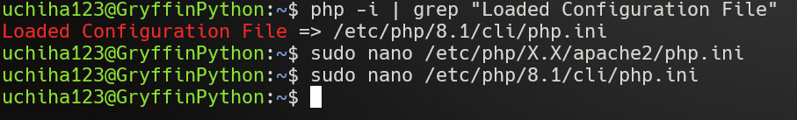

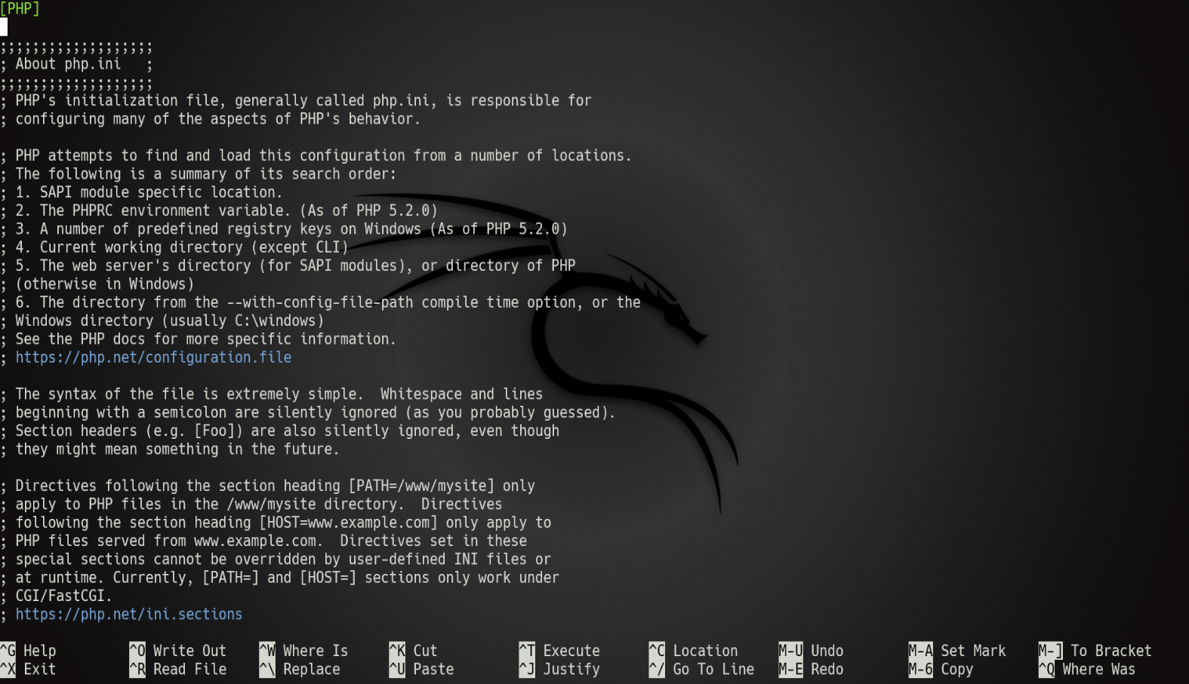

I have already configured the php file required to setup DVWA and completed the creation of mariadb DVWA database along with the authentication processes.

Setting Up the Database

Use the command sudo mariadb to open the mariadb database CLI in order to access and use the database.

Use these commands to initialize and build a database for DVWA.

DROP USER IF EXISTS ‘dvwauser’@’localhost’;

CREATE USER ‘dvwauser’@’localhost’ IDENTIFIED BY ‘passw0rd’;

CREATE DATABASE IF NOT EXISTS dvwa;

GRANT ALL PRIVILEGES ON dvwa.* TO ‘dvwauser’@’localhost’;

FLUSH PRIVILEGES;

EXIT;

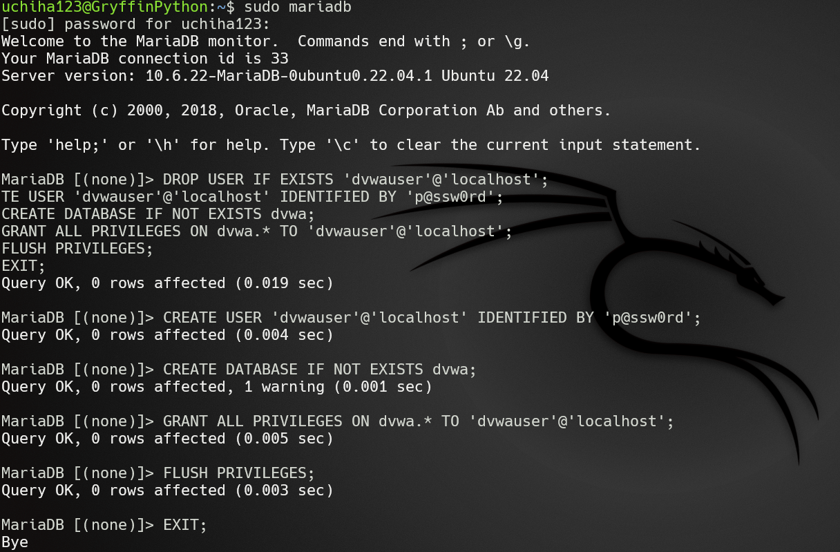

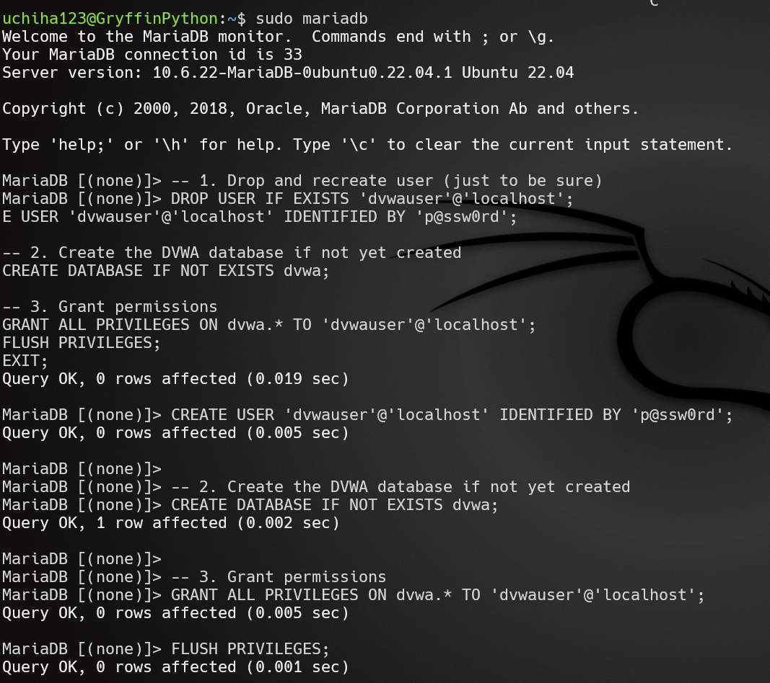

Starting the Web Application

We start the web application by using the commands: ‘sudo systemctl start apache2’ and ‘sudo systemctl start mariadb’ to start the applications that would help the DVWA application start.

Then we input the commands in the shell that allows the apache2 http server to access the /var/www/html/DVWA directory that allows the DVWA to actually be hosted on localhost.

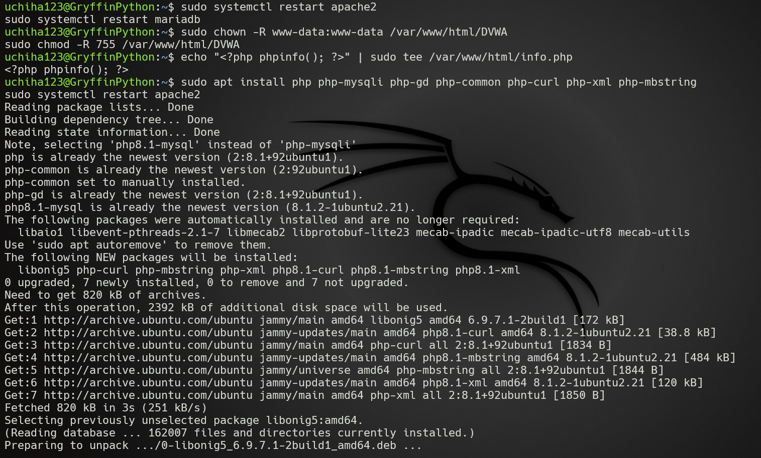

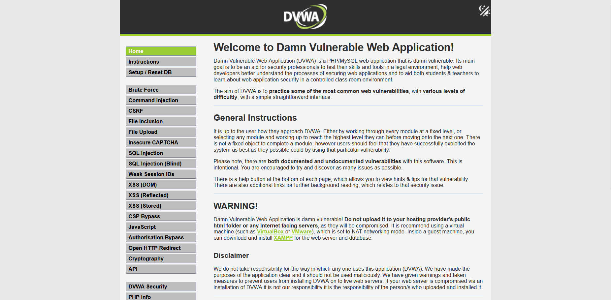

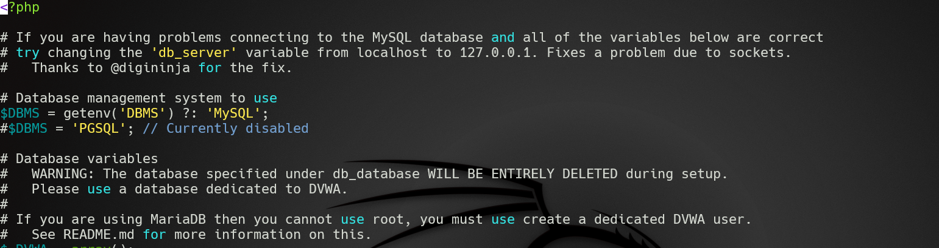

5 Web Vulnerabilities

Including XSS, SQLi and CSRF along with file upload vulnerability and login brute force vulnerability using Burpsuite, OWASP ZAP(WAPalyzer).

1. Brute Force

Using Burpsuite Intruder and Proxy to guess the username and password.

**Payload**:

* Used **Burp Suite Intruder** to guess credentials (e.g., admin:password).
* Automated requests with a wordlist (e.g., rockyou.txt).

**Impact**:

* Unauthorized access to user accounts.

**Mitigation**:

* Implement account lockouts and CAPTCHA.

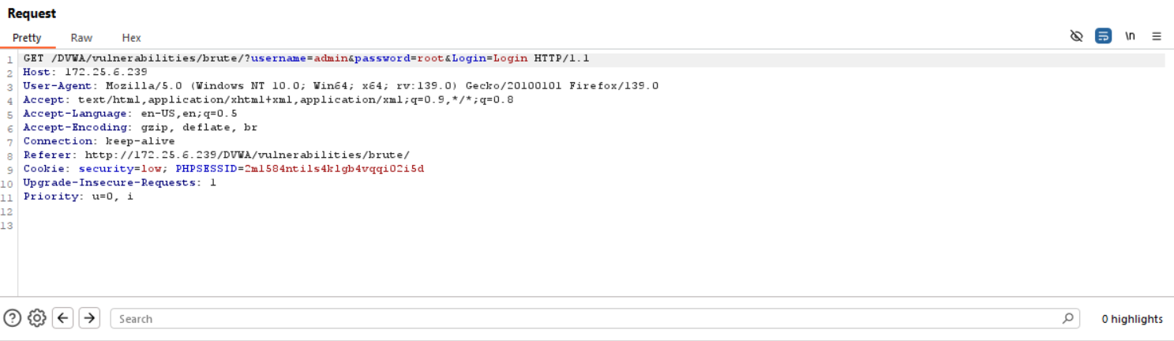

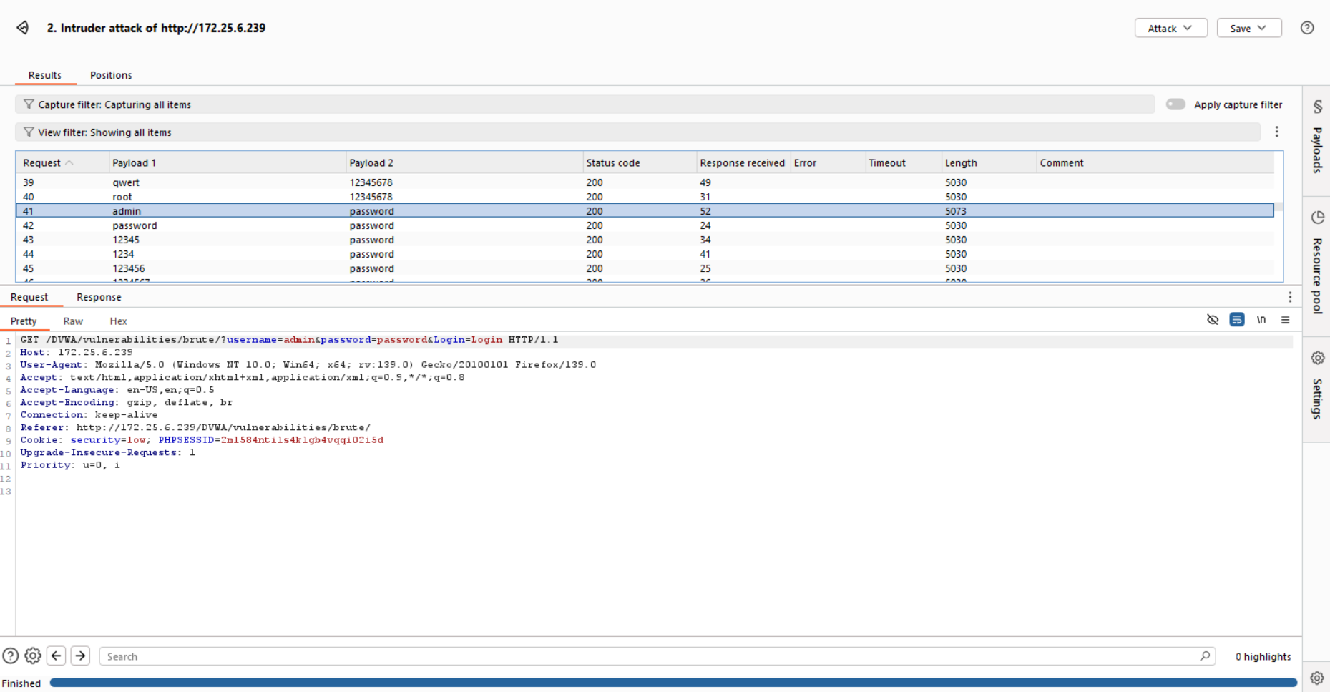

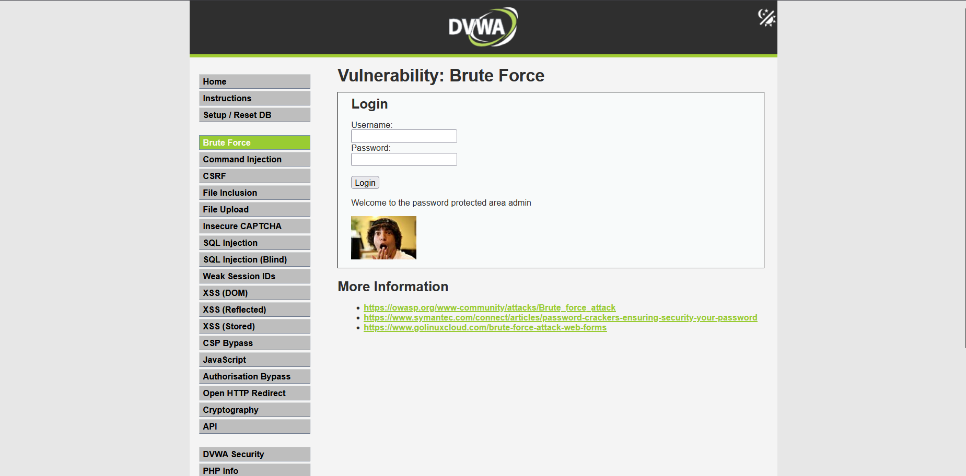

1. CSRF(Cross Site Request Forgery)

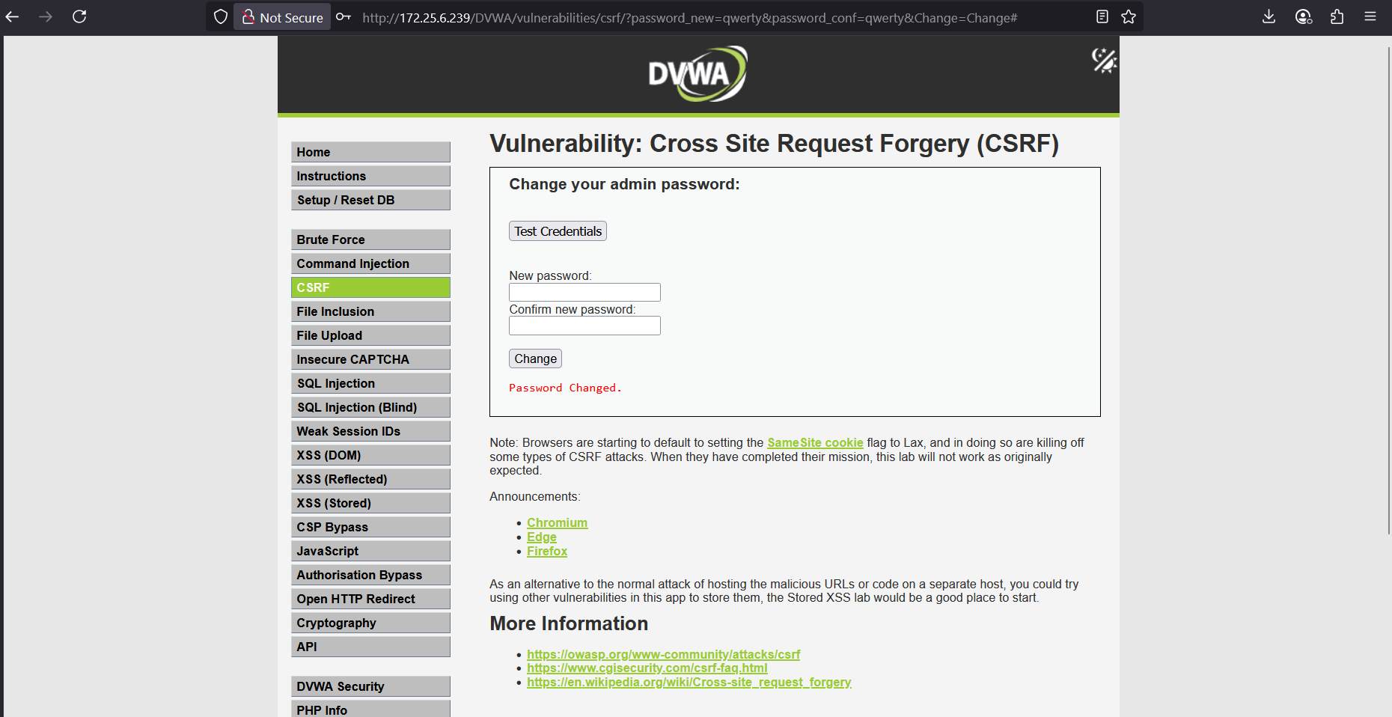



**Payload**:

* Crafted malicious link:

**Impact**:

* Attackers force users to change passwords unknowingly.

**Mitigation**:

* Use anti-CSRF tokens.

URL Tampering caused CSRF and can also be done by hackers sending web pages with links that contain the link of the password reset.

So by clicking the link in the web page the user unintentionally changes the password of his own account thereby logging him out of it while the hacker has the account credentials thereby allowing the hacker to manipulate the account and gain sensitive user information.

1. RCE via unrestricted file upload access



Code for the netcat connection. A reverse shell basically.

Go to the place where the uploaded file has been stored in the website. Once you go to the place the server executes the code in the file, connecting the server to the attacker machine thereby giving the attacker access to change the machine with the help of a shell.

Reverse shell is a type of attack in which the attacker sends a file containing code that when executed by the victim computer allows the victim computer to connect to the open port/listener of the hacker machine thereby bypassing firewall and IDS related alerts and security systems.

Executed commands via: sudo nc -lvnp 4444

**Impact**:

* Full server compromise.

**Mitigation**:

* Restrict file types and scan uploads.

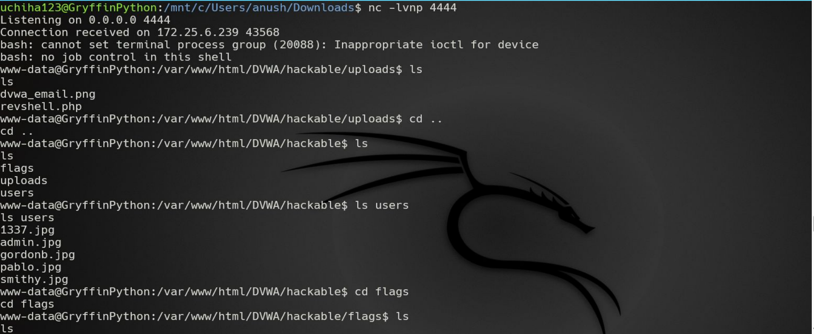

1. Command Injection

Payload: 127.0.0.1; cat /etc/passwd | tee /tmp/passwd

The above command is input by the user in the input form given to enter an ip address to ping the ip.

The starting of the command is the ip address which is the localhost, then the semicolon (;) which separates two commands from each other and can execute them together. The cat command displays the file specified by the user which was the /etc/passswd file.

The single line(|) symbol is used to take the output of the command that was executed to its left and bring that as the input of the command to the right which is ‘tee /tmp/passwd’.

The impact of this vulnerability is the leaking of secret system files that the hacker can make a knowledge of and use it to gather more information about the web application.

Mitigation: Sanitize user input (e.g., disallow ; , |).

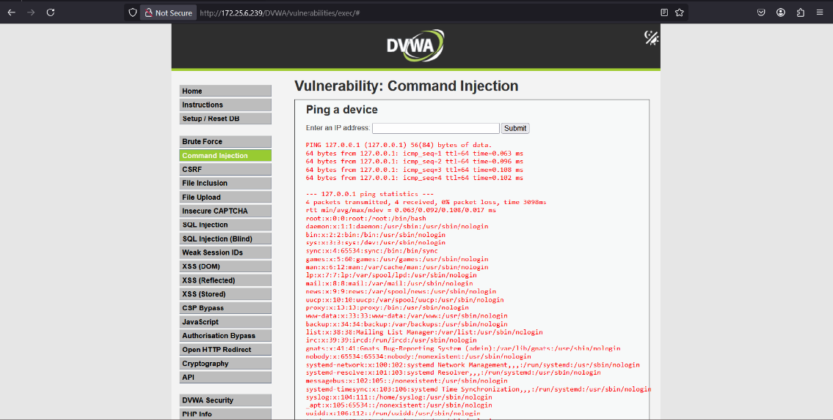

1. XSS (Cross Site Scripting)

Payload: <Script>alert(“rxss”) </Script>

The script tag has its first letter as capital so that the sanitization does not recognize the script word while the browser executes the command due to the word being the same.

The impact of this vulnerability is the ability of the hacker to steal cookies/session tokens.

Mitigation: Use CSP headers and output encoding.

